A Service of Thanksgiving for the Life of

‘GEORGE’

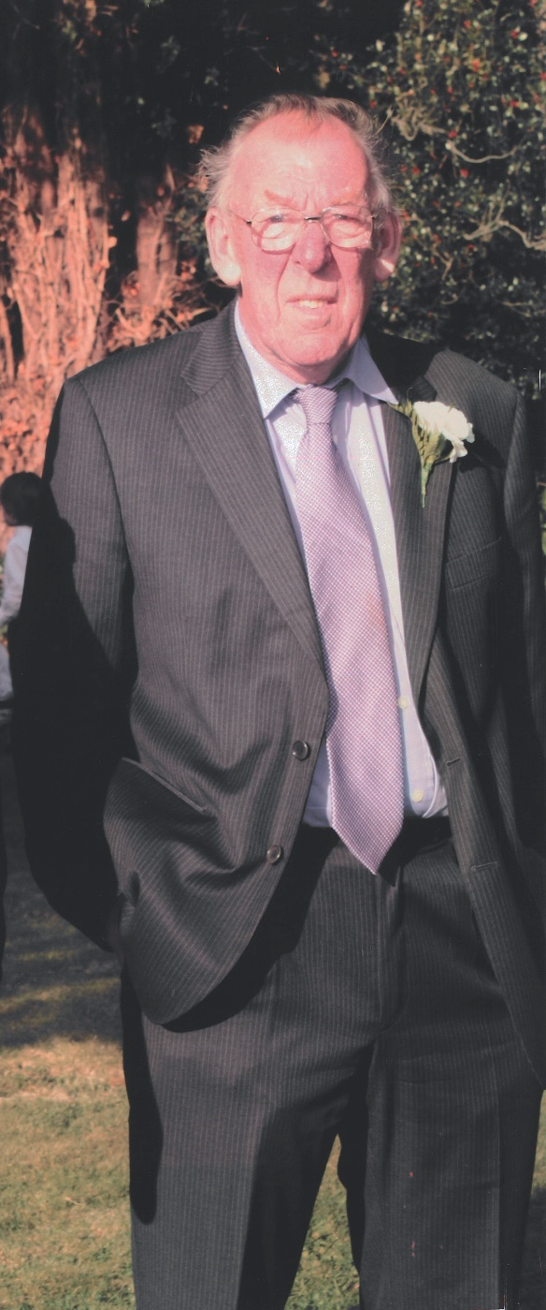

RONALD GEORGE CARD

29th March 1942 ~ 11th July 2022

Blandford St Mary Church
Tuesday 2nd August 2022 at 12pm

Service led by Reverend Carolyn Couzens

OPENING MUSIC
You Raise Me Up ~ Westlife

WELCOME

OPENING PRAYER

HYMN

Morning has broken,
Like the first morning,
Blackbird has spoken
Like the first bird;
Praise for the singing,
Praise for the morning,
Praise for them springing
Fresh from the Word.

Sweet the rain's new fall,
Sunlit from heaven,
Like the first dewfall
On the first grass;
Praise for the sweetness,
Of the wet garden,
Sprung in completeness
Where his feet pass.

Mine is the sunlight,
Mine is the morning,
Born of the one light
Eden saw play;
Praise with elation,
Praise every morning,
God's re-creation
Of the new day.

EULOGY

BIBLE READING
Psalm 23

PRAYERS

THE LORD’S PRAYER

Our Father, who art in heaven,
hallowed be thy name;
thy kingdom come; thy will be done;
on earth as it is in heaven.
Give us this day our daily bread.
And forgive us our trespasses,
as we forgive those who trespass against us.
And lead us not into temptation but deliver us from evil.
For thine is the kingdom, the power and the glory,
for ever and ever. Amen.

CLOSING MUSIC
I Am A Cider Drinker ~ The Wurzels

Please join the family as they make their way to George’s final resting place in the church yard.

PRAYER

COMMENDATION

COMMITTAL

BLESSING

Thank you for attending this service to give Thanks for
George’s wonderful life.

You are warmly invited to join the family for refreshments at
The Royal British Legion, Church Lane, Blandford, DT11 7AD.

Donations in memory of George can be made to

Battersea Cats & Dogs Home

Online at www.funeraldirector.co.uk/ronald-card

Alternatively, C/O Lesley Shand Funeral Service, 28 East Street,
Blandford Forum, DT11 7DR.

Tel: 01258 453425

© CCLI 501003

